St Gregory’s Catholic Primary School
Loving and Learning
Newsletter 1 September 8th 2023
This half-term we are Grateful and Generous.
Welcome back!
Welcome back after what seems like a very short Summer break! I hope that all had an opportunity to relax and enjoy time together as a family. On Wednesday, it was lovely to see all the children looking so smart in their uniforms. Welcome to any new families and to our new members of staff. We are all looking forward to an exciting year here at St Gregory’s. On behalf of the staff, can I thank you for your continued support.
Fr Cownley RIP
Yesterday, you will have heard the sad news about the death of Fr Cownley who served this parish and school for 22 years. As soon as I made aware of any funeral arrangements, I will share them with you. We continue to pray for Fr Cownley, his family and friends.
PE Kits
A reminder that we have changed our PE kit – this is now a light blue t shirt and black shorts. I have spoken with the company who sell shirts with our logo on, and they can provide shirts in the new colour (parents/carers are under no obligation to purchase a ‘badged’ shirt – a simple, plain light blue T shirt is absolutely fine).
PE Days
A copy of the PE timetable is appended to this document for your information.
School Calendar
In order to improve communication between home and school, the calendar on our website has been improved and will be regularly updated. The calendar can be found at:
https://www.st-gregorys.sandwell.sch.uk/Page/Calendar
If there are any last-minute changes, you will be informed via email.

Diversity Working Group
If any parents/carers are interested in joining the new Diversity Working Group, the first meeting will be on Monday 18th September at 3.35 in the Hall. We will be discussing how we can make Black History Month in October a celebration of the lived experience of our families and the local community. If you cannot make the meeting but have some ideas, please get in touch with me. I have already selected new House Saints who I think will be relevant role-models for our pupils.
Year 6 Admissions Meeting
Thank you to all the parents/carers who attended the information meeting yesterday. The lady who led the meeting said it was her biggest ever turnout!
Parent Workshops
This year, we will be running a number of parent/carer workshops on how you can support your child’s learning. Details to follow.
School Council
Next week, we will be having elections for our new School Council. Pupils are going to be given a much bigger voice in the school (they are the most important people in it). We will also be bringing back the Mini-Vinnies who will be leading on work with our community as well as a new CAFOD Club which will look at how we can support a project overseas.
Argos
A huge thank you to Argos in Bearwood who have donated several much-needed fans to the school. They are very much appreciated by all the pupils and staff.
Enjoy the weekend. If like me, you are a massive fan of Rugby Union, best of luck to your team in the Rugby World Cup (as long as it is Ireland!).
Mark Paine
Principal

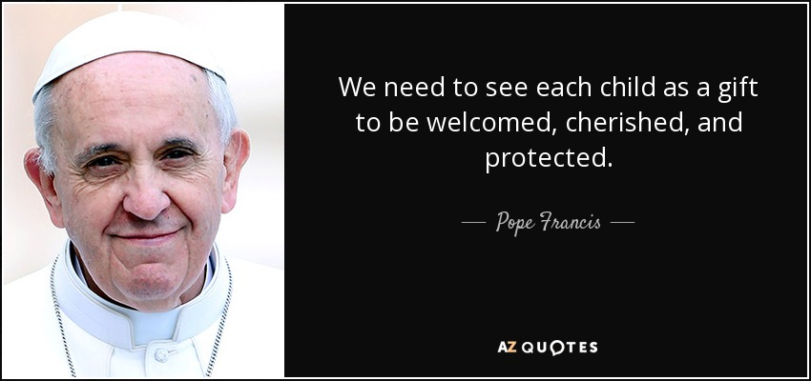

Masses at Our Lady of Good Counsel and St Gregory the Great are at:
5pm (Saturday Vigil); 9 am and 11 am on Sundays

PE Timetable 2023-2024
Lesson | Monday | Tuesday | Wednesday | Thursday | Friday
1 |  | Music |  | Mass
2 | Rec | Music | Nursery | Mass | Year 3
12:00-1:00 | Lunch | Lunch | Lunch | Lunch | Lunch
3 | Year 6 | Music | Year 5 | Year 2 | Year 4
4 | Year 6 | Music |  | Year 1 | Assembly 2:30

